EAS Reporting Module
A Quick Guide

1. EAS Reporting Module Reports

These reports will display the data related to the EAS(Electronic Approval System). There are 5 dashboards in this module
To Navigate to this module login into BI instance using the below url.
http://192.168.166.203:9704/analytics/saw.dll?bieehome&startPage=1

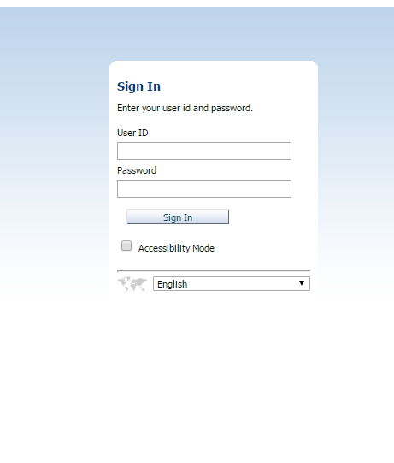

Enter the below Credentials
User ID : (Respective Accounting team users)
Password : Their password

Once Logged in then navigate to the dashboards and select EAS Dashboard under Corporate.

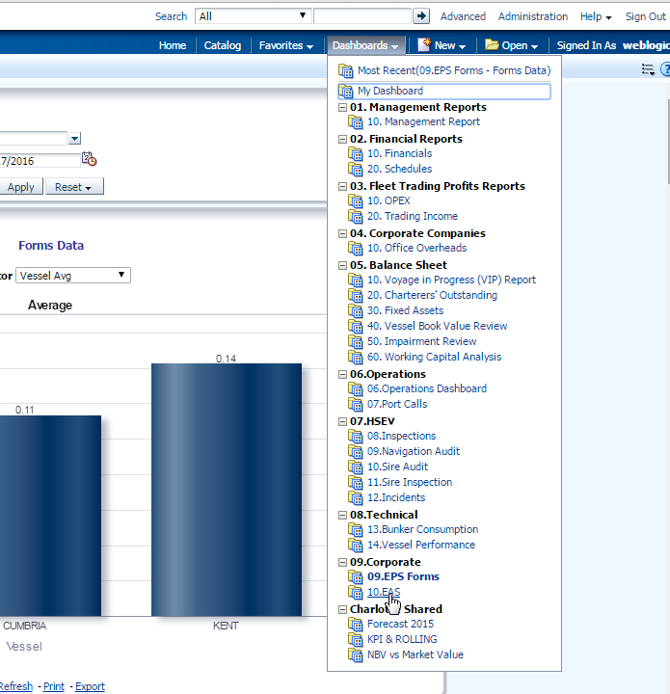

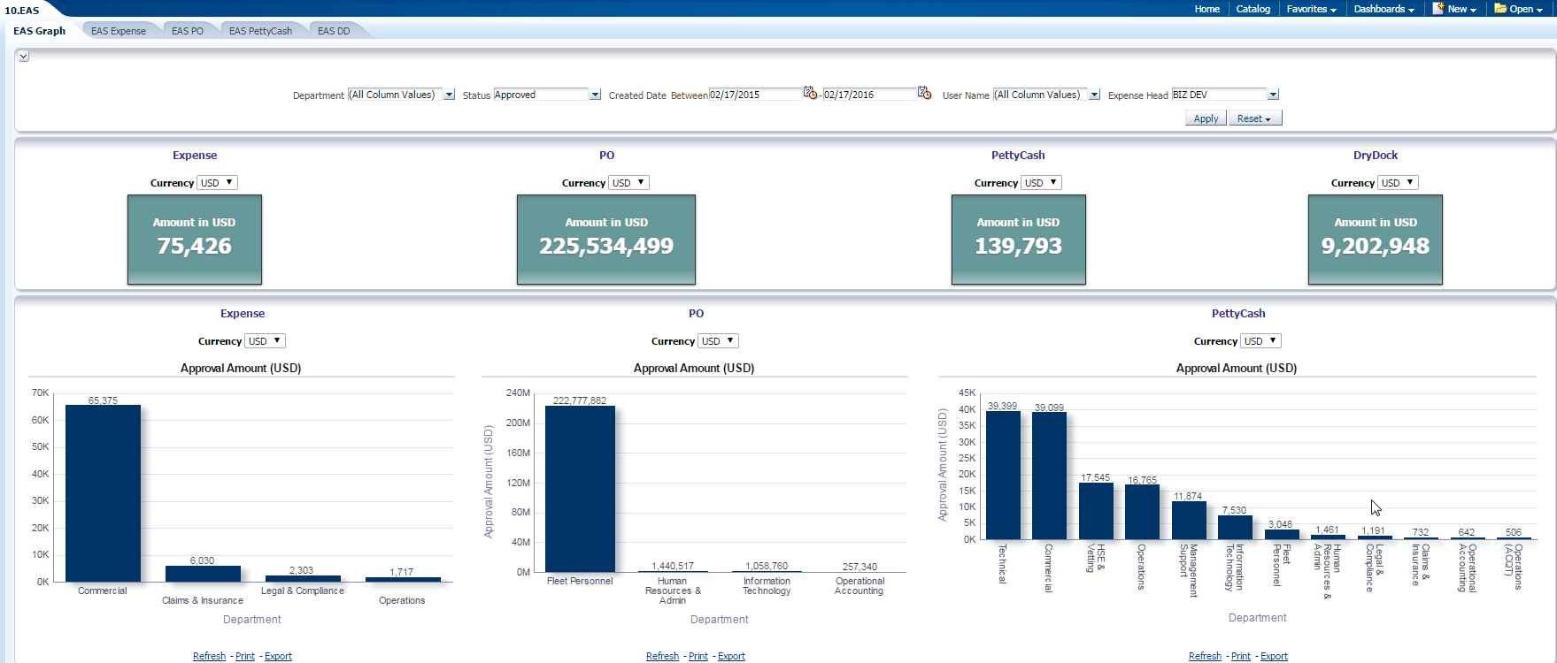

There are individual reports for the each type of expense. And these detailed reports are drillable to the lowest level of information.
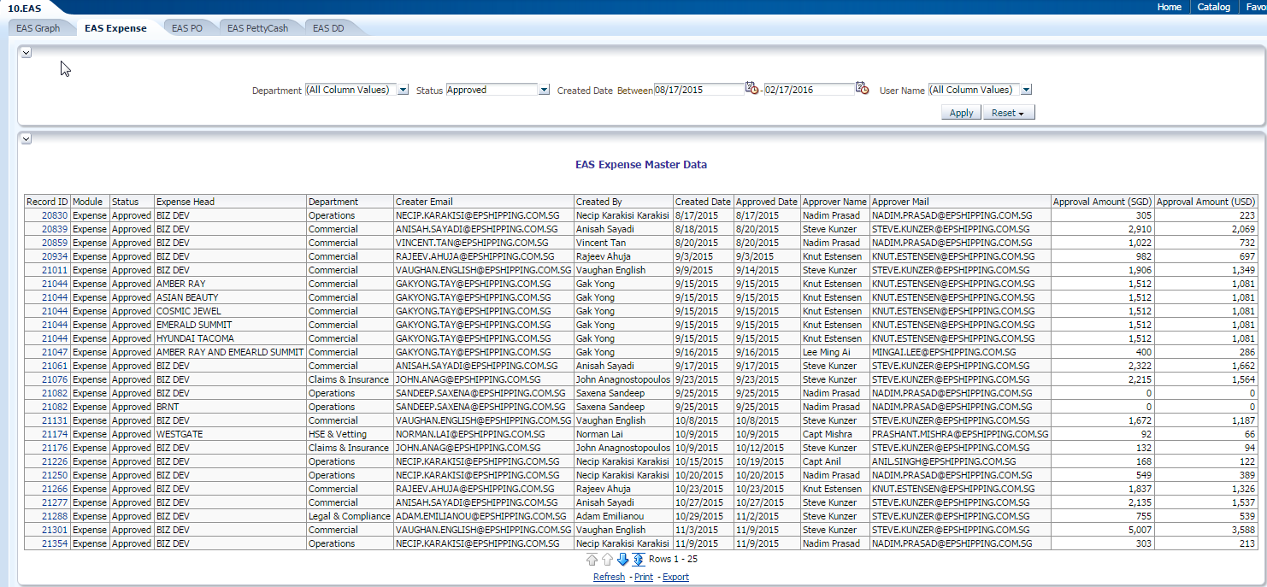

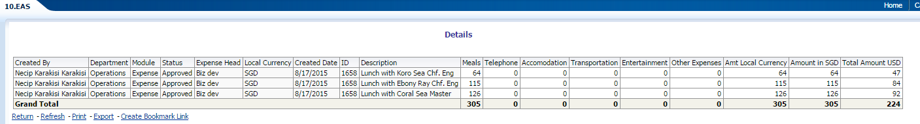

- There are 5 dashboards for the Corporate dashboards.
    - EAS Graph : This provides the graphical representation of the data for the selected data points by department,status,dates,user,expense head(For the type Expense)
    - EAS Expense: This provides the
Tabular representation of the data of Expense related for the selected data points by department,status,dates,user,expense head(For the type Expense)
and these detailed reports are drillable to the lowest level of information.
    - EAS PettyCash: This provides the
Tabular representation of the data of pettycash for the selected data points by department,status,dates,user and these detailed reports are drillable to the lowest level of information.
    - EAS PO: This provides the
Tabular representation of the data of PO for the selected data points by department,status,dates,user and these detailed reports are drillable to the lowest level of information.
    - EAS DD: This provides the
Tabular representation of the data of DryDock for the selected data points by department,status,dates,user and these detailed reports are drillable to the lowest level of information.

Parameters for the EAS Graph Dashboard:
- Department : Department Name like Finance,Accounting etc
- Status : Status of the record. Approved,Pending,Rejected
- Date : Duration with in which the data to be fetched.
- User name : To Search all the information related to a particular user.
- Expense Head( Expense reports) : The Group to which the expense belongs to.

